Robert Minson

February 16, 2023

SYM-408

Prof. Dilts

XML Basics Application

Select statement in the person.person table looking for xml file of everyone with the first name John

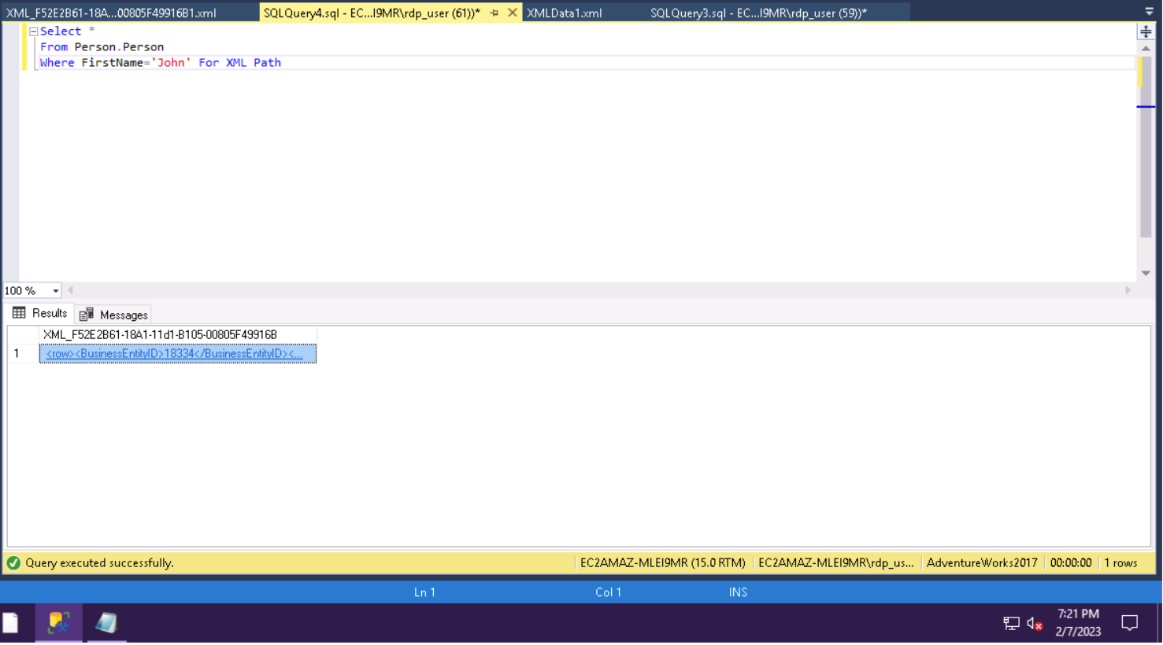

Saving the xml document with all of the Johns in the company to the documents folder as an xml document.

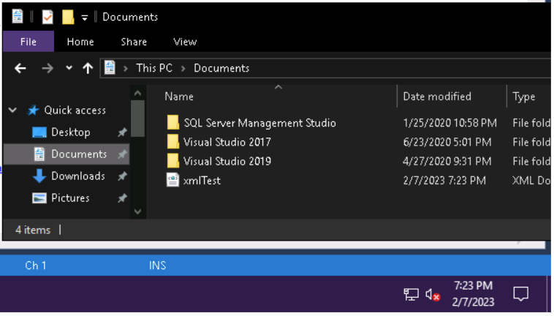

Query selecting the table that the xml document was placed in and the result with the link of the xml document

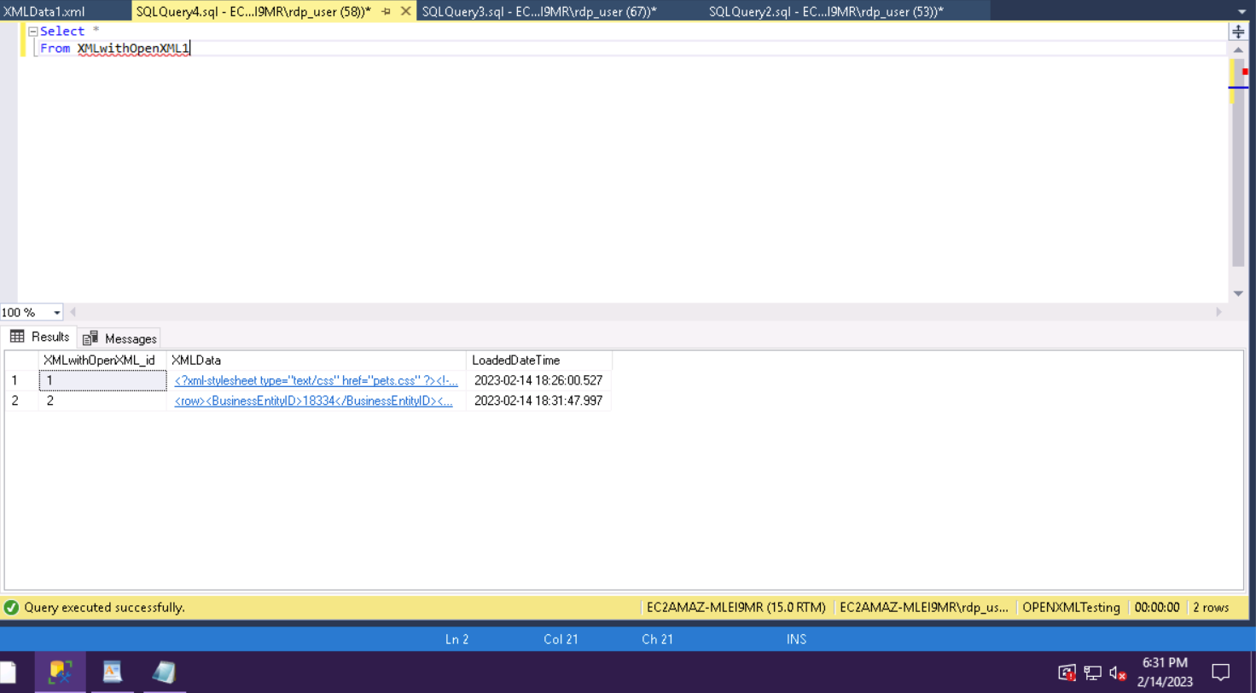

The contents of the link of the xml document in sql.

